Exception Handling in Java

The **exception handling in java** is one of the powerful *mechanism to handle the runtime errors* so that normal flow of the application can be maintained.

In this page, we will learn about java exception, its type and the difference between checked and unchecked exceptions.

What is exception

**Dictionary Meaning:** Exception is an abnormal condition.

In java, exception is an event that disrupts the normal flow of the program. It is an object which is thrown at runtime.

What is exception handling

Exception Handling is a mechanism to handle runtime errors such as ClassNotFound, IO, SQL, Remote etc.

Advantage of Exception Handling

The core advantage of exception handling is **to maintain the normal flow of the application**. Exception normally disrupts the normal flow of the application that is why we use exception handling. Let's take a scenario:

1. statement 1;
2. statement 2;
3. statement 3;
4. statement 4;
5. statement 5;//exception occurs
6. statement 6;
7. statement 7;
8. statement 8;
9. statement 9;
10. statement 10;

Suppose there is 10 statements in your program and there occurs an exception at statement 5, rest of the code will not be executed i.e. statement 6 to 10 will not run. If we perform exception handling, rest of the statement will be executed. That is why we use exception handling in java.

## Hierarchy of Java Exception classeshierarchy of exception handling

### Types of Exception

There are mainly two types of exceptions: checked and unchecked where error is considered as unchecked exception. The sun microsystem says there are three types of exceptions:

1. Checked Exception
2. Unchecked Exception
3. Error

## Difference between checked and unchecked exceptions

### 1) Checked Exception

The classes that extend Throwable class except RuntimeException and Error are known as checked exceptions e.g.IOException, SQLException etc. Checked exceptions are checked at compile-time.

### 2) Unchecked Exception

The classes that extend RuntimeException are known as unchecked exceptions e.g. ArithmeticException, NullPointerException, ArrayIndexOutOfBoundsException etc. Unchecked exceptions are not checked at compile-time rather they are checked at runtime.

### 3) Error

Error is irrecoverable e.g. OutOfMemoryError, VirtualMachineError, AssertionError etc.

### Common scenarios where exceptions may occur

There are given some scenarios where unchecked exceptions can occur. They are as follows:

### 1) Scenario where ArithmeticException occurs

If we divide any number by zero, there occurs an ArithmeticException.

1. **int** a=50/0;//ArithmeticException

### 2) Scenario where NullPointerException occurs

If we have null value in any variable, performing any operation by the variable occurs an NullPointerException.

1. String s=**null**;
2. System.out.println(s.length());//NullPointerException

### 3) Scenario where NumberFormatException occurs

The wrong formatting of any value, may occur NumberFormatException. Suppose I have a string variable that have characters, converting this variable into digit will occur NumberFormatException.

1. String s="abc";
2. **int** i=Integer.parseInt(s);//NumberFormatException

### 4) Scenario where ArrayIndexOutOfBoundsException occurs

If you are inserting any value in the wrong index, it would result ArrayIndexOutOfBoundsException as shown below:

1. **int** a[]=**new** **int**[5];
2. a[10]=50; //ArrayIndexOutOfBoundsException

## Java Exception Handling Keywords

There are 5 keywords used in java exception handling.

1. try
2. catch
3. finally
4. throw
5. throws

## Java try block

Java try block is used to enclose the code that might throw an exception. It must be used within the method.

Java try block must be followed by either catch or finally block.

#### Syntax of java try-catch

1. **try**{
2. //code that may throw exception
3. }
4. **catch**(Exception_class_Name ref){}

#### Syntax of try-finally block

1. **try**{
2. //code that may throw exception
3. }**finally**{}

## Java catch block

Java catch block is used to handle the Exception. It must be used after the try block only.

You can use multiple catch block with a single try.

## Problem without exception handling

Let's try to understand the problem if we don't use try-catch block.

1. **public** **class** Testtrycatch1{
2. **public** **static** **void** main(String args[]){
3. **int** data=50/0;//may throw exception
4. System.out.println("rest of the code...");
5. }
6. }

[**Test it Now**](http://www.javatpoint.com/opr/test.jsp?filename=Testtrycatch1)

Output:

Exception in thread main java.lang.ArithmeticException:/ by zero

As displayed in the above example, rest of the code is not executed (in such case, rest of the code... statement is not printed).

There can be 100 lines of code after exception. So all the code after exception will not be executed.

## Solution by exception handling

Let's see the solution of above problem by java try-catch block.

1. **public** **class** Testtrycatch2{
2. **public** **static** **void** main(String args[]){
3. **try**{
4. **int** data=50/0;
5. }
6. **catch**(ArithmeticException e)
7. {
8. System.out.println(e);
9. }
10. System.out.println("rest of the code...");
11. }
12. }

[**Test it Now**](http://www.javatpoint.com/opr/test.jsp?filename=Testtrycatch2)

Output:

Exception in thread main java.lang.ArithmeticException:/ by zero

rest of the code...

Now, as displayed in the above example, rest of the code is executed i.e. rest of the code... statement is printed.

## Internal working of java try-catch block

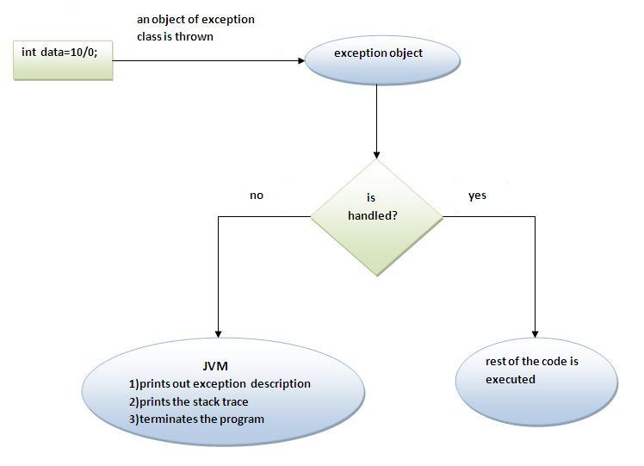

The JVM firstly checks whether the exception is handled or not. If exception is not handled, JVM provides a default exception handler that performs the following tasks:

* Prints out exception description.
* Prints the stack trace (Hierarchy of methods where the exception occurred).
* Causes the program to terminate.

But if exception is handled by the application programmer, normal flow of the application is maintained i.e. rest of the code is executed.

## Java Multi catch block

If you have to perform different tasks at the occurrence of different Exceptions, use java multi catch block.

Let's see a simple example of java multi-catch block.

1. **public** **class** TestMultipleCatchBlock{
2. **public** **static** **void** main(String args[]){
3. **try**{
4. **int** a[]=**new** **int**[5];
5. a[5]=30/0;
6. }
7. **catch**(ArithmeticException e){System.out.println("task1 is completed");}
8. **catch**(ArrayIndexOutOfBoundsException e){System.out.println("task 2 completed");}
9. **catch**(Exception e){System.out.println("common task completed");}
11. System.out.println("rest of the code...");
12. }
13. }

[**Test it Now**](http://www.javatpoint.com/opr/test.jsp?filename=TestMultipleCatchBlock)

Output:task1 completed

rest of the code...

#### Rule: At a time only one Exception is occured and at a time only one catch block is executed.

#### Rule: All catch blocks must be ordered from most specific to most general i.e. catch for ArithmeticException must come before catch for Exception .

1. **class** TestMultipleCatchBlock1{
2. **public** **static** **void** main(String args[]){
3. **try**{
4. **int** a[]=**new** **int**[5];
5. a[5]=30/0;
6. }
7. **catch**(Exception e){System.out.println("common task completed");}
8. **catch**(ArithmeticException e){System.out.println("task1 is completed");}
9. **catch**(ArrayIndexOutOfBoundsException e){System.out.println("task 2 completed");}
10. System.out.println("rest of the code...");
11. }
12. }

[**Test it Now**](http://www.javatpoint.com/opr/test.jsp?filename=TestMultipleCatchBlock1)

Output:

Compile-time error

# Java Nested try block

The try block within a try block is known as nested try block in java.

### Why use nested try block

Sometimes a situation may arise where a part of a block may cause one error and the entire block itself may cause another error. In such cases, exception handlers have to be nested.

### Syntax:

1. ....
2. **try**
3. {
4. statement 1;
5. statement 2;
6. **try**
7. {
8. statement 1;
9. statement 2;
10. }
11. **catch**(Exception e)
12. {
13. }
14. }
15. **catch**(Exception e)
16. {
17. }
18. ....

## Java nested try example

Let's see a simple example of java nested try block.

1. **class** Excep6{
2. **public** **static** **void** main(String args[]){
3. **try**{
4. **try**{
5. System.out.println("going to divide");
6. **int** b =39/0;
7. }**catch**(ArithmeticException e){System.out.println(e);}
9. **try**{
10. **int** a[]=**new** **int**[5];
11. a[5]=4;
12. }**catch**(ArrayIndexOutOfBoundsException e){System.out.println(e);}
14. System.out.println("other statement);
15. }
16. **catch**(Exception e){System.out.println("handeled");}
18. System.out.println("normal flow..");
19. }
20. }

# Java finally block

**Java finally block** is a block that is used to execute important code such as closing connection, stream etc.

Java finally block is always executed whether exception is handled or not.

Java finally block follows try or catch block.

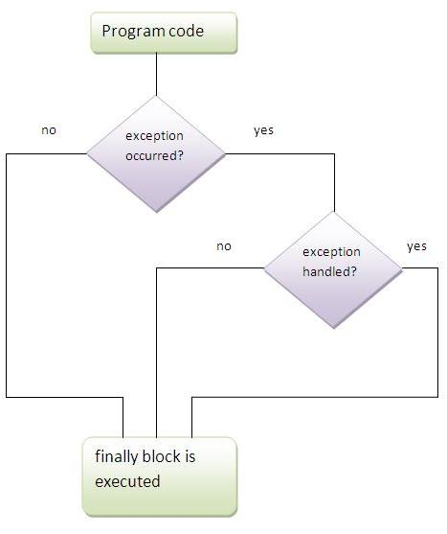

#### Note: If you don't handle exception, before terminating the program, JVM executes finally block(if any).

## Why use java finally

* Finally block in java can be used to put "cleanup" code such as closing a file, closing connection etc.

## Usage of Java finally

Let's see the different cases where java finally block can be used.

### Case 1

Let's see the java finally example where **exception doesn't occur**.

1. **class** TestFinallyBlock{
2. **public** **static** **void** main(String args[]){
3. **try**{
4. **int** data=25/5;
5. System.out.println(data);
6. }
7. **catch**(NullPointerException e){System.out.println(e);}
8. **finally**{System.out.println("finally block is always executed");}
9. System.out.println("rest of the code...");
10. }
11. }

[**Test it Now**](http://www.javatpoint.com/opr/test.jsp?filename=TestFinallyBlock)

Output:5

finally block is always executed

rest of the code...

### Case 2

Let's see the java finally example where **exception occurs and not handled**.

1. **class** TestFinallyBlock1{
2. **public** **static** **void** main(String args[]){
3. **try**{
4. **int** data=25/0;
5. System.out.println(data);
6. }
7. **catch**(NullPointerException e){System.out.println(e);}
8. **finally**{System.out.println("finally block is always executed");}
9. System.out.println("rest of the code...");
10. }
11. }

[**Test it Now**](http://www.javatpoint.com/opr/test.jsp?filename=TestFinallyBlock1)

Output:finally block is always executed

Exception in thread main java.lang.ArithmeticException:/ by zero

### Case 3

Let's see the java finally example where **exception occurs and handled**.

1. **public** **class** TestFinallyBlock2{
2. **public** **static** **void** main(String args[]){
3. **try**{
4. **int** data=25/0;
5. System.out.println(data);
6. }
7. **catch**(ArithmeticException e){System.out.println(e);}
8. **finally**{System.out.println("finally block is always executed");}
9. System.out.println("rest of the code...");
10. }
11. }

[**Test it Now**](http://www.javatpoint.com/opr/test.jsp?filename=TestFinallyBlock2)

Output:Exception in thread main java.lang.ArithmeticException:/ by zero

finally block is always executed

rest of the code...

#### Rule: For each try block there can be zero or more catch blocks, but only one finally block.

#### Note: The finally block will not be executed if program exits(either by calling System.exit() or by causing a fatal error that causes the process to abort).

## Java throw keyword

The Java throw keyword is used to explicitly throw an exception.

We can throw either checked or uncheked exception in java by throw keyword. The throw keyword is mainly used to throw custom exception. We will see custom exceptions later.

The syntax of java throw keyword is given below.

**throw** exception;

Let's see the example of throw IOException.

**throw** **new** IOException("sorry device error);

## java throw keyword example

In this example, we have created the validate method that takes integer value as a parameter. If the age is less than 18, we are throwing the ArithmeticException otherwise print a message welcome to vote.

1. **public** **class** TestThrow1{
2. **static** **void** validate(**int** age)
3. {
4. **if**(age<18)
5. **throw** **new** ArithmeticException("not valid");
6. **else**
7. System.out.println("welcome to vote");
8. }
9. **public** **static** **void** main(String args[]){
10. validate(13);
11. System.out.println("rest of the code...");
12. }
13. }

[**Test it Now**](http://www.javatpoint.com/opr/test.jsp?filename=TestThrow1)

Output:

Exception in thread main java.lang.ArithmeticException:not valid

Java throws keyword

The **Java throws keyword** is used to declare an exception. It gives an information to the programmer that there may occur an exception so it is better for the programmer to provide the exception handling code so that normal flow can be maintained.

Exception Handling is mainly used to handle the checked exceptions. If there occurs any unchecked exception such as NullPointerException, it is programmers fault that he is not performing check up before the code being used.

Syntax of java throws

1. return_type method_name() **throws** exception_class_name{
2. //method code
3. }

Which exception should be declared

**Ans)** checked exception only, because:

* **unchecked Exception:** under your control so correct your code.
* **error:** beyond your control e.g. you are unable to do anything if there occurs VirtualMachineError or StackOverflowError.

Advantage of Java throws keyword

Now Checked Exception can be propagated (forwarded in call stack).

It provides information to the caller of the method about the exception.

## Java throws example

Let's see the example of java throws clause which describes that checked exceptions can be propagated by throws keyword.

1. **import** java.io.IOException;
2. **class** Testthrows1{
3. **void** m()**throws** IOException{
4. **throw** **new** IOException("device error");//checked exception
5. }
7. **void** p(){
8. **try**{
9. m();
10. }**catch**(Exception e){System.out.println("exception handled");}
11. }
12. **public** **static** **void** main(String args[]){
13. Testthrows1 obj=**new** Testthrows1();
14. obj.p();
15. System.out.println("normal flow...");
16. }
17. }

[**Test it Now**](http://www.javatpoint.com/opr/test.jsp?filename=Testthrows1)

Output:

exception handled

normal flow...

### Rule: If you are calling a method that declares an exception, you must either caught or declare the exception.

|  |
| --- |
| There are two cases:   1. **Case1:**You caught the exception i.e. handle the exception using try/catch. 2. **Case2:**You declare the exception i.e. specifying throws with the method. |

### Case1: You handle the exception

* In case you handle the exception, the code will be executed fine whether exception occurs during the program or not.

1. **import** java.io.*;
2. **class** M{
3. **void** method()**throws** IOException{
4. **throw** **new** IOException("device error");
5. }
6. }
7. **public** **class** Testthrows2{
8. **public** **static** **void** main(String args[]){
9. **try**{
10. M m=**new** M();
11. m.method();
12. }
13. **catch**(Exception e){System.out.println("exception handled" + e);}
15. System.out.println("normal flow...");
16. }
17. }

[**Test it Now**](http://www.javatpoint.com/opr/test.jsp?filename=Testthrows2)

Output:exception handled

normal flow...

### Case2: You declare the exception

* A)In case you declare the exception, if exception does not occur, the code will be executed fine.
* B)In case you declare the exception if exception occures, an exception will be thrown at runtime because throws does not handle the exception.

***A)Program if exception does not occur***

1. **import** java.io.*;
2. **class** M{
3. **void** method()**throws** IOException{
4. System.out.println("device operation performed");
5. }
6. }
7. **class** Testthrows3{
8. **public** **static** **void** main(String args[])**throws** IOException{//declare exception
9. M m=**new** M();
10. m.method();
12. System.out.println("normal flow...");
13. }
14. }

[**Test it Now**](http://www.javatpoint.com/opr/test.jsp?filename=Testthrows3)

Output:device operation performed

normal flow...

***B)Program if exception occurs***

1. **import** java.io.*;
2. **class** M{
3. **void** method()**throws** IOException{
4. **throw** **new** IOException("device error");
5. }
6. }
7. **class** Testthrows4{
8. **public** **static** **void** main(String args[])**throws** IOException{//declare exception
9. M m=**new** M();
10. m.method();
12. System.out.println("normal flow...");
13. }
14. }

[**Test it Now**](http://www.javatpoint.com/opr/test.jsp?filename=Testthrows4)

Output: device error .Runtime Exception

# Difference between throw and throws in Java

There are many differences between throw and throws keywords. A list of differences between throw and throws are given below:

|  |  |  |
| --- | --- | --- |
| **No.** | **throw** | **throws** |
| 1) | Java throw keyword is used to explicitly throw an exception. | Java throws keyword is used to declare an exception. |
| 2) | Checked exception cannot be propagated using throw only. | Checked exception can be propagated with throws. |
| 3) | Throw is followed by an instance. | Throws is followed by class. |
| 4) | Throw is used within the method. | Throws is used with the method signature. |
| 5) | You cannot throw multiple exceptions. | You can declare multiple exceptions e.g. public void method()throws IOException,SQLException. |

## Java throw example

1. **void** m(){
2. **throw** **new** ArithmeticException("sorry");
3. }

## Java throws example

1. **void** m()**throws** ArithmeticException{
2. //method code
3. }

## Java throw and throws example

1. **void** m()**throws** ArithmeticException{
2. **throw** **new** ArithmeticException("sorry");
3. }

# Difference between final, finally and finalize

There are many differences between final, finally and finalize. A list of differences between final, finally and finalize are given below:

|  |  |  |  |
| --- | --- | --- | --- |
| **No.** | **final** | **finally** | **finalize** |
| 1) | Final is used to apply restrictions on class, method and variable. Final class can't be inherited, final method can't be overridden and final variable value can't be changed. | Finally is used to place important code, it will be executed whether exception is handled or not. | Finalize is used to perform clean up processing just before object is garbage collected. |
| 2) | Final is a keyword. | Finally is a block. | Finalize is a method. |

## Java final example

1. **class** FinalExample{
2. **public** **static** **void** main(String[] args){
3. **final** **int** x=100;
4. x=200;//Compile Time Error
5. }}

## Java finally example

1. **class** FinallyExample{
2. **public** **static** **void** main(String[] args){
3. **try**{
4. **int** x=300;
5. }**catch**(Exception e){System.out.println(e);}
6. **finally**{System.out.println("finally block is executed");}
7. }}

## Java finalize example

1. **class** FinalizeExample{
2. **public** **void** finalize(){System.out.println("finalize called");}
3. **public** **static** **void** main(String[] args){
4. FinalizeExample f1=**new** FinalizeExample();
5. FinalizeExample f2=**new** FinalizeExample();
6. f1=**null**;
7. f2=**null**;
8. System.gc();
9. }}